Fake News Detection using Machine Learning

Fake news on different platforms is spreading widely and is a matter of serious concern, as it causes social wars and permanent breakage of the bonds established among people. A lot of research is already going on focused on the classification of fake news.
Here we will try to solve this issue with the help of machine learning in Python.
Before starting the code, download the dataset by clicking the link.
Steps to be followed
- Importing Libraries and Datasets
- Data Preprocessing
- Preprocessing and analysis of News column
- Converting text into Vectors
- Model training, Evaluation, and Prediction

Importing Libraries and Datasets
The libraries used are :
- Pandas: For importing the dataset.
- Seaborn/Matplotlib: For data visualization.

import pandas as pd
import seaborn as sns
import matplotlib.pyplot as plt

Let’s import the downloaded dataset.
data = pd.read_csv('News.csv',index_col=0)
data.head()

Output :
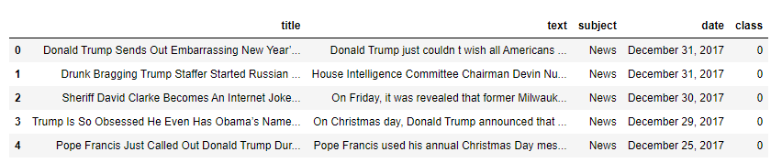

Data preprocessing
The shape of the dataset can be found by the below code.
data.shape
Output:
(44919, 5)

As the title, subject and date column will not going to be helpful in identification of the news. So, we can drop these column.
data = data.drop(["title", "subject","date"], axis = 1)
Now, we have to check if there is any null value (we will drop those rows)
data.isnull().sum()

Output:
text 0
class 0
So there is no null value.
Now we have to shuffle the dataset to prevent the model to get bias. After that we will reset the index and then drop it. Because index column is not useful to us.
# Shuffling
data = data.sample(frac=1)
data.reset_index(inplace=True)
data.drop(["index"], axis=1, inplace=True)

Now Let’s explore the unique values in the each category using below code.
sns.countplot(data=data, x='class', order=data['class'].value_counts().index)

Output:
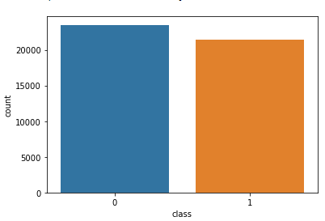
unique values in the each category

Preprocessing and analysis of News column
Firstly we will remove all the stopwords, punctuations and any irrelevant spaces from the text. For that NLTK Library is required and some of it’s module need to be downloaded. So, for that run the below code.
from tqdm import tqdm
import re
import nltk
nltk.download('punkt')
nltk.download('stopwords')
from nltk.corpus import stopwords
from nltk.tokenize import word_tokenize
from nltk.stem.porter import PorterStemmer
from wordcloud import WordCloud

Once we have all the required modules, we can create a function name preprocess text. This function will preprocess all the data given as input.
def preprocess_text(text_data):
preprocessed_text = []
for sentence in tqdm(text_data):
sentence = re.sub(r'[^\w\s]', '', sentence)
preprocessed_text.append(' '.join(token.lower()
for token in str(sentence).split()
if token not in stopwords.words('english')))
return preprocessed_text

To implement the function in all the news in the text column, run the below command.
preprocessed_review = preprocess_text(data['text'].values)
data['text'] = preprocessed_review

This command will take some time (as the dataset taken is very large).

Let’s visualize the WordCloud for fake and real news separately.
# Real
consolidated = ' '.join(
word for word in data['text'][data['class'] == 1].astype(str))
wordCloud = WordCloud(width=1600,
height=800,
random_state=21,
max_font_size=110,
collocations=False)
plt.figure(figsize=(15, 10))
plt.imshow(wordCloud.generate(consolidated), interpolation='bilinear')
plt.axis('off')
plt.show()
Output :
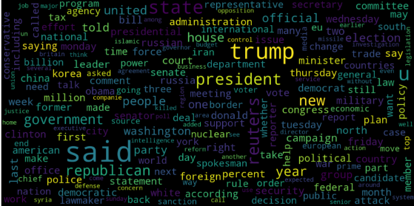

# Fake
consolidated = ' '.join(
word for word in data['text'][data['class'] == 0].astype(str))
wordCloud = WordCloud(width=1600,
height=800,
random_state=21,
max_font_size=110,
collocations=False)
plt.figure(figsize=(15, 10))
plt.imshow(wordCloud.generate(consolidated), interpolation='bilinear')
plt.axis('off')
plt.show()

Output :
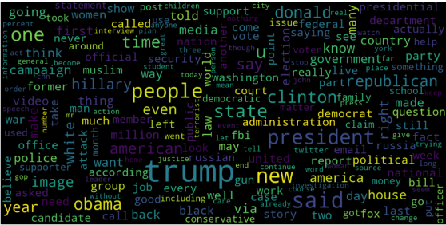

Now, Let’s plot the bargraph of the top 20 most frequent words.

from sklearn.feature_extraction.text import CountVectorizer
def get_top_n_words(corpus, n=None):
vec = CountVectorizer().fit(corpus)
bag_of_words = vec.transform(corpus)
sum_words = bag_of_words.sum(axis=0)
words_freq = [(word, sum_words[0, idx])
for word, idx in vec.vocabulary_.items()]
words_freq = sorted(words_freq, key=lambda x: x[1],
reverse=True)
return words_freq[:n]
common_words = get_top_n_words(data['text'], 20)
df1 = pd.DataFrame(common_words, columns=['Review', 'count'])
df1.groupby('Review').sum()['count'].sort_values(ascending=False).plot(
kind='bar',
figsize=(10, 6),
xlabel="Top Words",
ylabel="Count",
title="Bar Chart of Top Words Frequency"
)

Output :
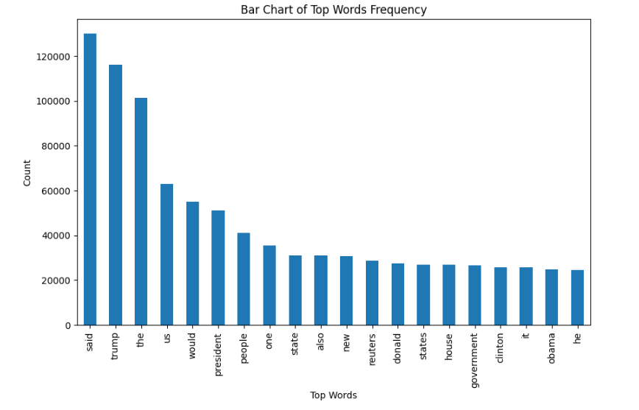
bargraph of the top 20 most frequent words

Converting text into Vectors
Before converting the data into vectors, split it into train and test.
from sklearn.model_selection import train_test_split
from sklearn.metrics import accuracy_score
from sklearn.linear_model import LogisticRegression
x_train, x_test, y_train, y_test = train_test_split(data['text'], data['class'], test_size=0.25)

Now we can convert the training data into vectors using TfidfVectorizer.

from sklearn.feature_extraction.text import TfidfVectorizer
vectorization = TfidfVectorizer()
x_train = vectorization.fit_transform(x_train)
x_test = vectorization.transform(x_test)

Model training, Evaluation, and Prediction
Now, the dataset is ready to train the model.
For training we will use Logistic Regression and evaluate the prediction accuracy using accuracy_score.
from sklearn.linear_model import LogisticRegression
model = LogisticRegression()
model.fit(x_train, y_train)
# testing the model
print(accuracy_score(y_train, model.predict(x_train)))
print(accuracy_score(y_test, model.predict(x_test)))

Output :
0.993766511324171
0.9893143365983972

Let’s train with Decision Tree Classifier.
from sklearn.tree import DecisionTreeClassifier
model = DecisionTreeClassifier()
model.fit(x_train, y_train)
# testing the model
print(accuracy_score(y_train, model.predict(x_train)))
print(accuracy_score(y_test, model.predict(x_test)))

Output :
0.9999703167205913
0.9951914514692787

The confusion matrix for Decision Tree Classifier can be implemented with the code below.
# Confusion matrix of Results from Decision Tree classification
from sklearn import metrics
cm = metrics.confusion_matrix(y_test, model.predict(x_test))
cm_display = metrics.ConfusionMatrixDisplay(confusion_matrix=cm, display_labels=[False,True])
cm_display.plot()
plt.show()

Output :
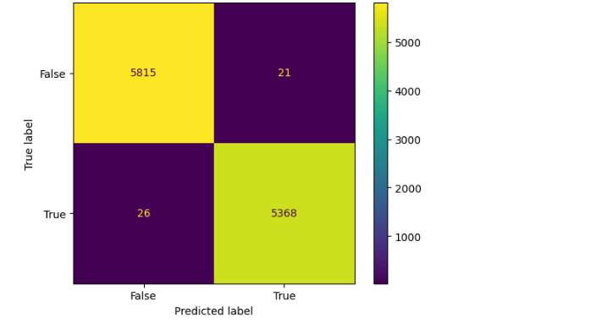
confusion matrix

Conclusion
Decision Tree Classifier and Logistic regression are performing well.

